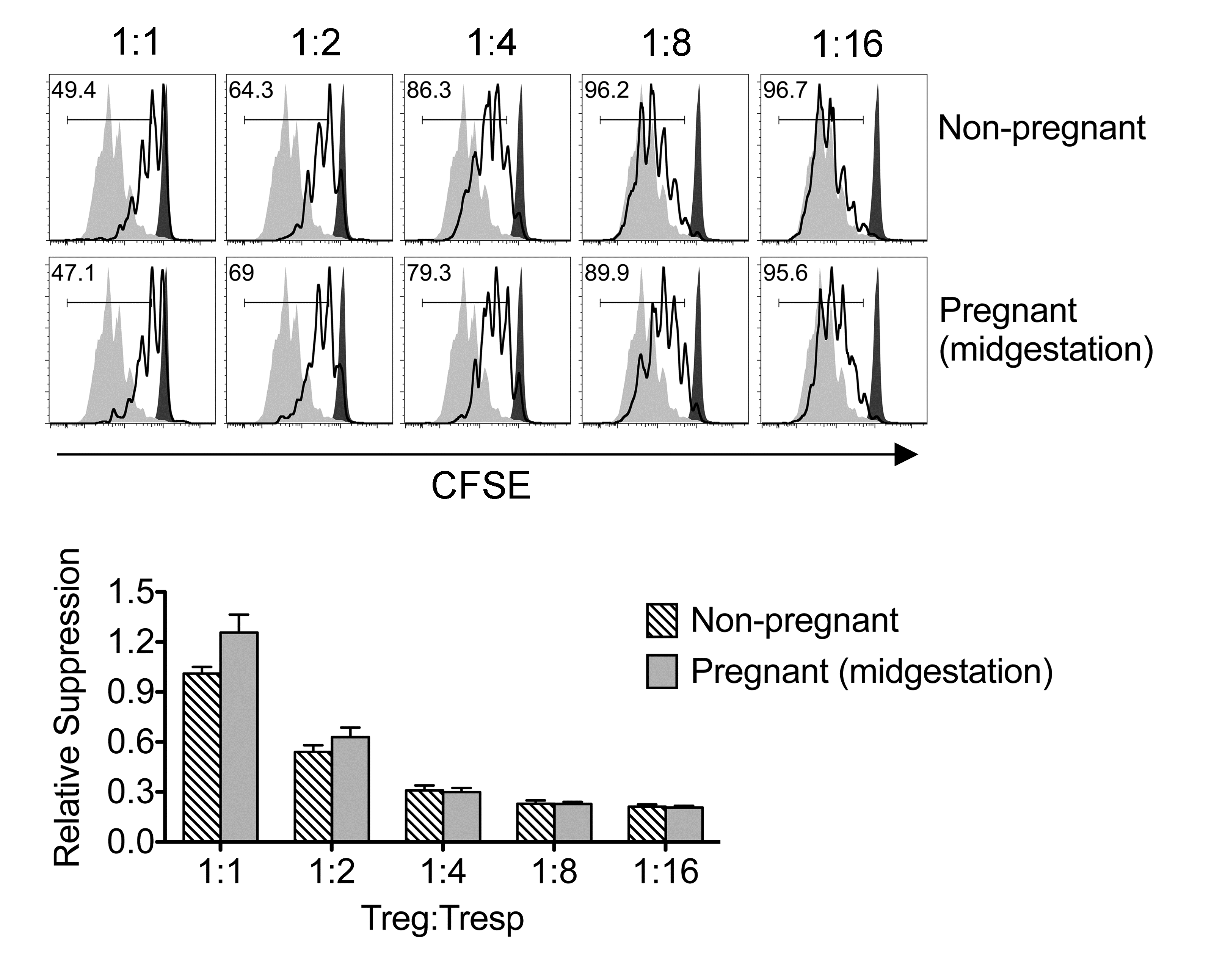

Figure S1. Pregnancy does not induce shifts in maternal regulatory CD4 T cell suppressive potency. Representative plots demonstrating proliferation (CFSE dilution) among responder CD90.1⁺ CD8 cells (Tresp) after co-culture with each ratio of GFP⁺ Tregs isolated from virgin or pregnant C57Bl/6 mice midgestation after mating with Balb/c males, and stimulation with anti-CD3 antibody (black line), compared with no Treg (gray filled) or no stimulation (black filled) controls (top). Relative suppression of responder cell proliferation (CFSE dilution) after co-culture with GFP⁺ Tregs for the mice described above normalized to suppression by GFP⁺ cells from non-pregnant controls at a 1:1 Treg:Tresp ratio (bottom).

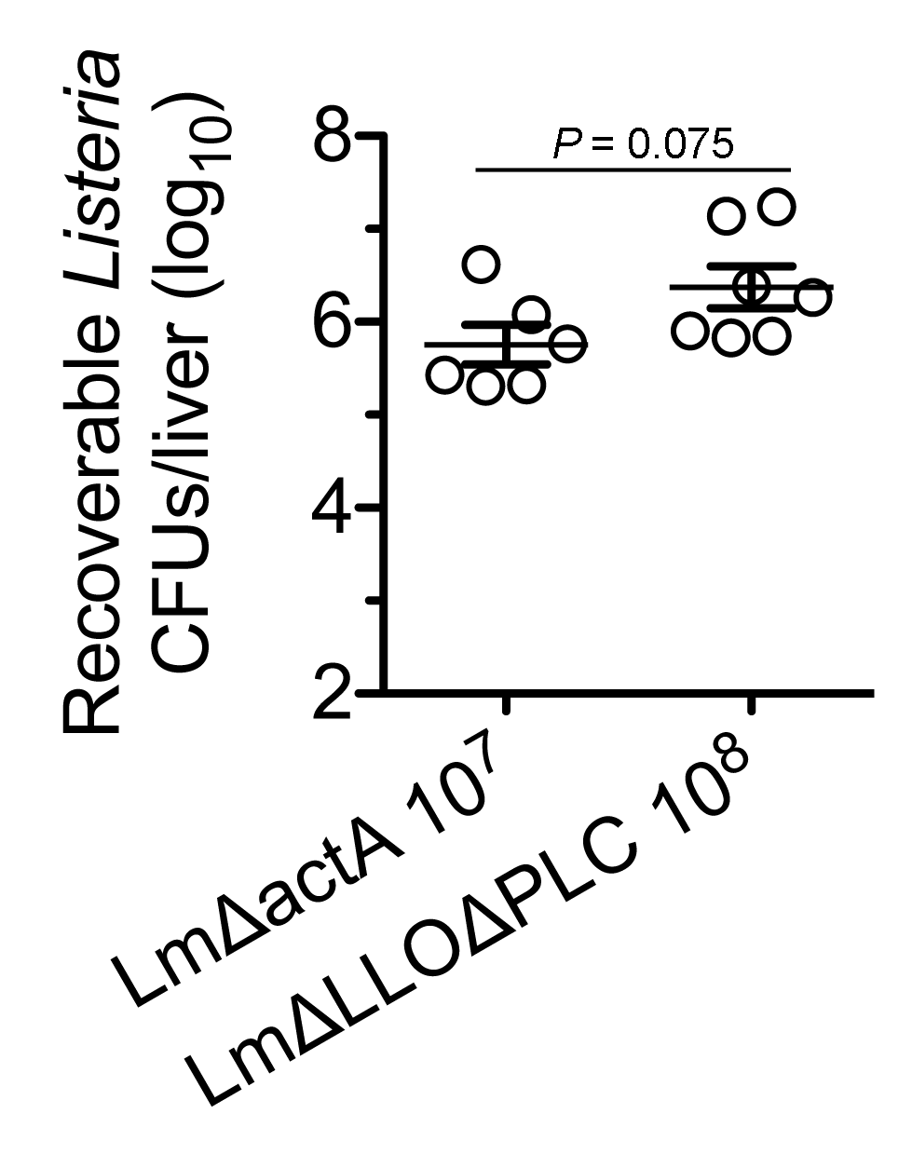

Figure S2. Comparable in vivo bacterial burden after LmΔactA and LmΔLLOΔPLC infection. Number of recoverable CFUs in the liver one-day after infection with 10⁷ LmΔactA compared with 10⁸ LmΔLLOΔPLC. Each data point represents results from an individual mouse from two independent experiments each with similar results.

