Australovenator wintonensis

Table S 16. Tooth measurements (mm).

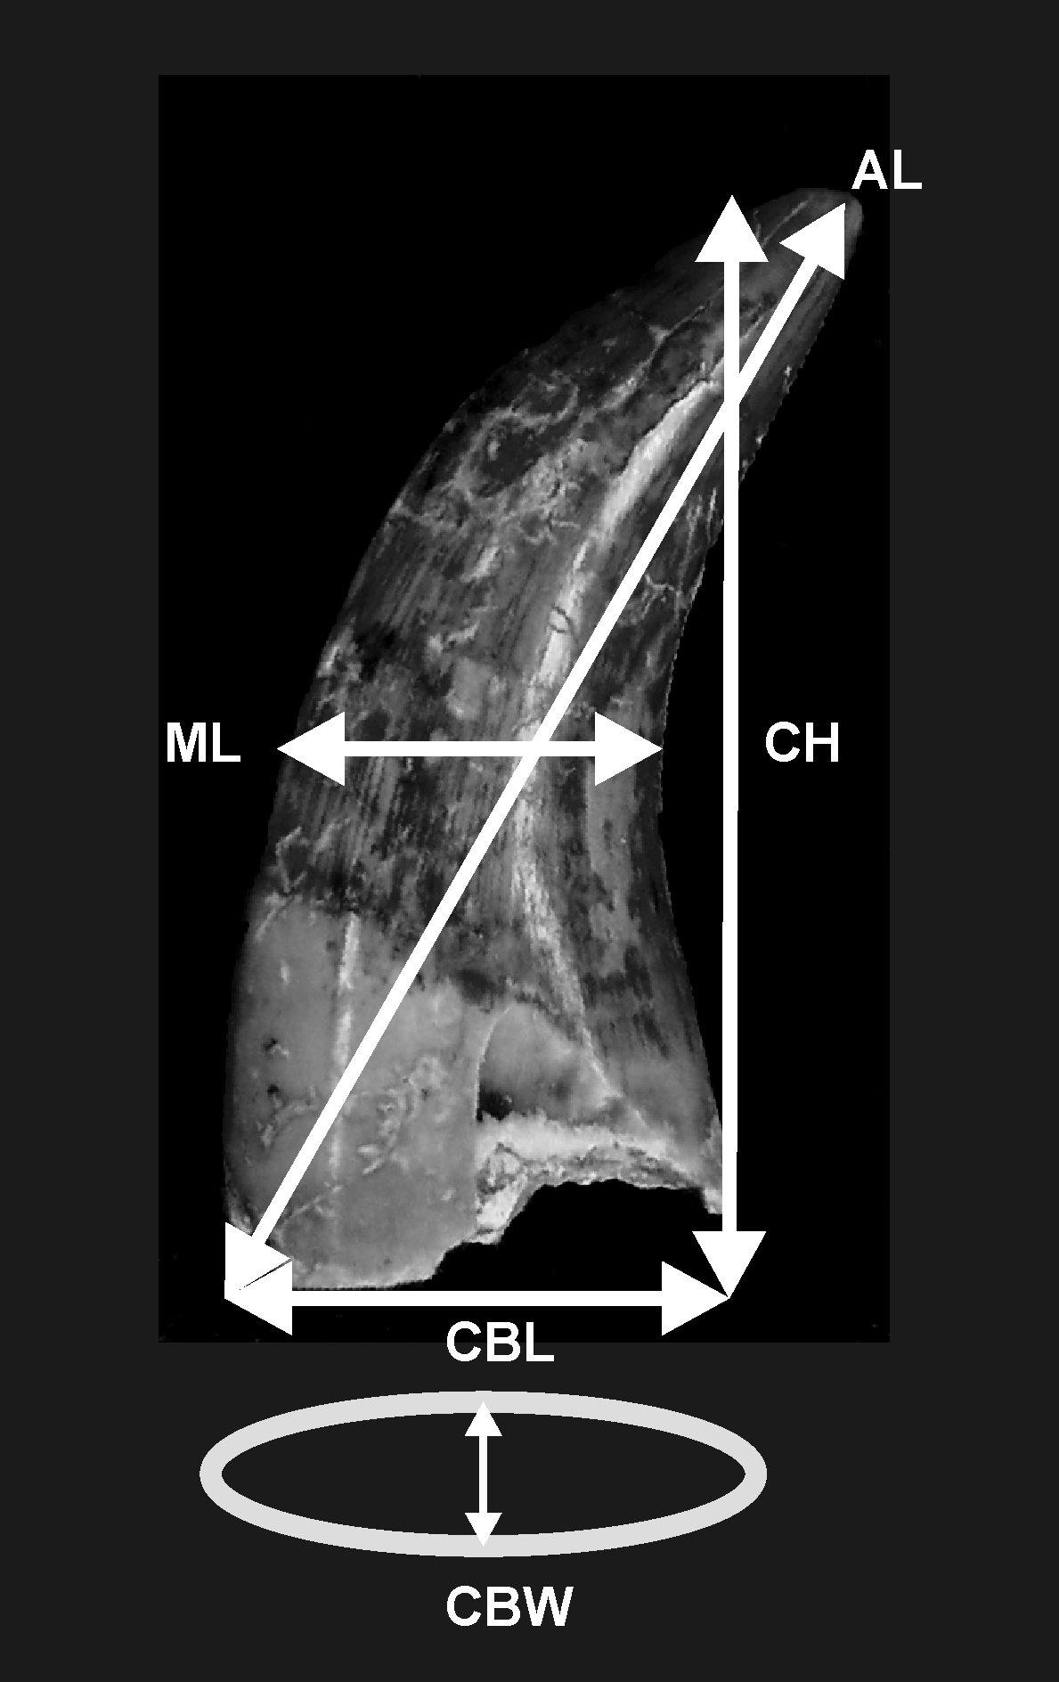

AODF 604 | AL | CH | CBL | ML | CBW
-343a | 16.26 | 12.53 | 8.32 | 6.29 | 3.99
-343b | 23.66 | 20.85 | 11.11 | 10.03 | 5.94
-342 | 20.10 | 17.21 | 9.3 | 8.24 | 4.97
-344 | 25.60 | 21.97 | 10.81 | 9.3 | 6.37
-341 | 14.45 | 13.83 | 7.16 | 5.46 | 5.12
-346 | - | 24.91 | - | 9.13 | -
-219 | 29.61+ | 23.36 | 12.62+ | 9.98 | 7.52
-42 | 16.65 | 14.62 | 6.84 | 6.00 | 5.25
-33 | - | 23.63+ | 10.55 | - | -

