**The raw numerical data for Figure 1**

|  |  |  |  |  |  |  |  |
| --- | --- | --- | --- | --- | --- | --- | --- |
| **Histopathologic Damage Score** | | | | | | | |
| **Control** | | **LPS** | | **Control+AMD3100** | | **LPS+AMD3100** | |
| Pathologist1 | Pathologist2 | Pathologist1 | Pathologist2 | Pathologist1 | Pathologist2 | Pathologist1 | Pathologist2 |
| 0 | 0 | 4 | 4 | 0 | 0 | 2 | 2.5 |
| 1 | 1 | 4 | 3.5 | 1 | 0.5 | 1 | 1.5 |
| 1 | 0.5 | 5 | 4.5 | 0 | 0.5 | 3 | 2.5 |
| 1 | 1 | 3 | 3 | 1 | 1 | 2 | 1.5 |
| 0 | 0 | 3 | 3.5 | 2 | 2 | 2 | 2 |
| 1 | 1.5 | 5 | 4.5 | 0 | 0 | 2 | 1.5 |
| 1 | 0.5 | 3 | 3 | 1 | 1 | 1 | 0.5 |

**Hematoxylin and eosin staining**

**The** **full lung image**

**The Control group**

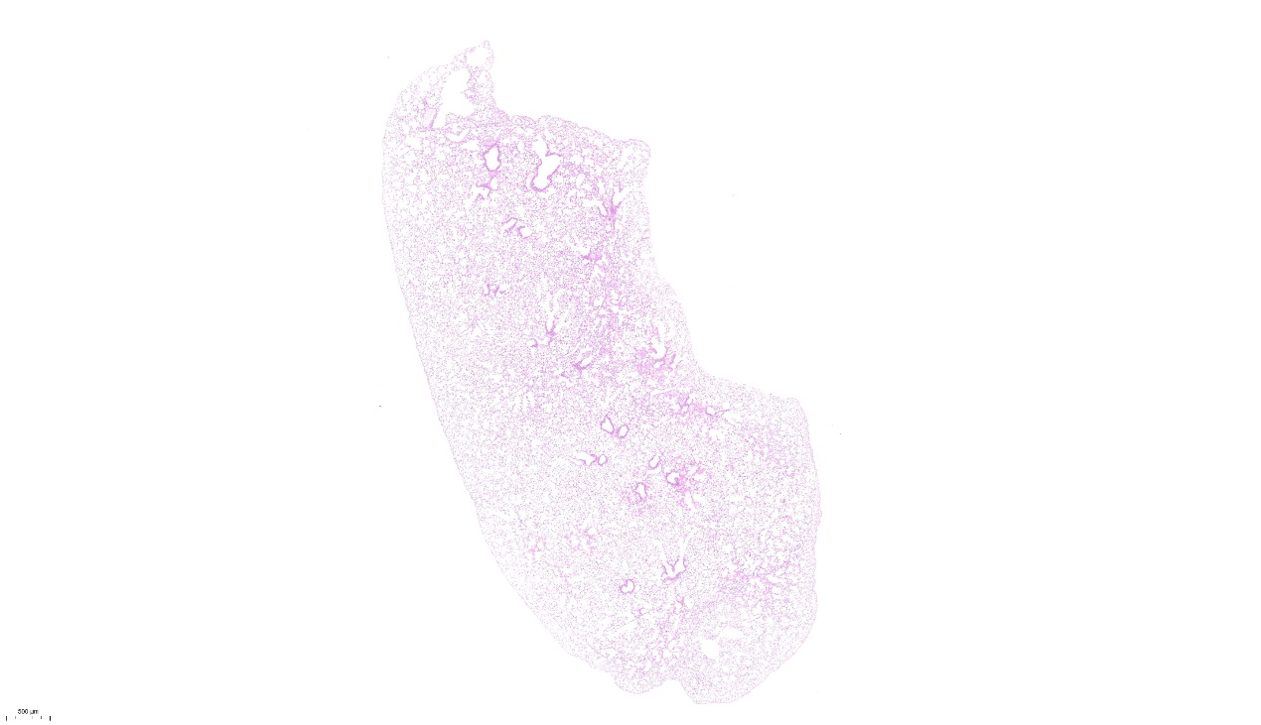

**The LPS group**

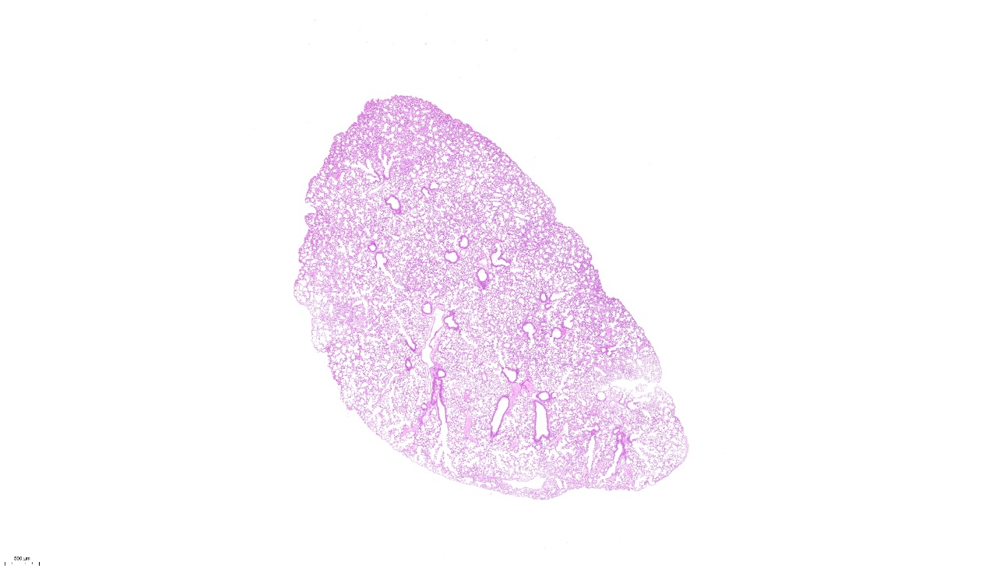

**The AMD group**

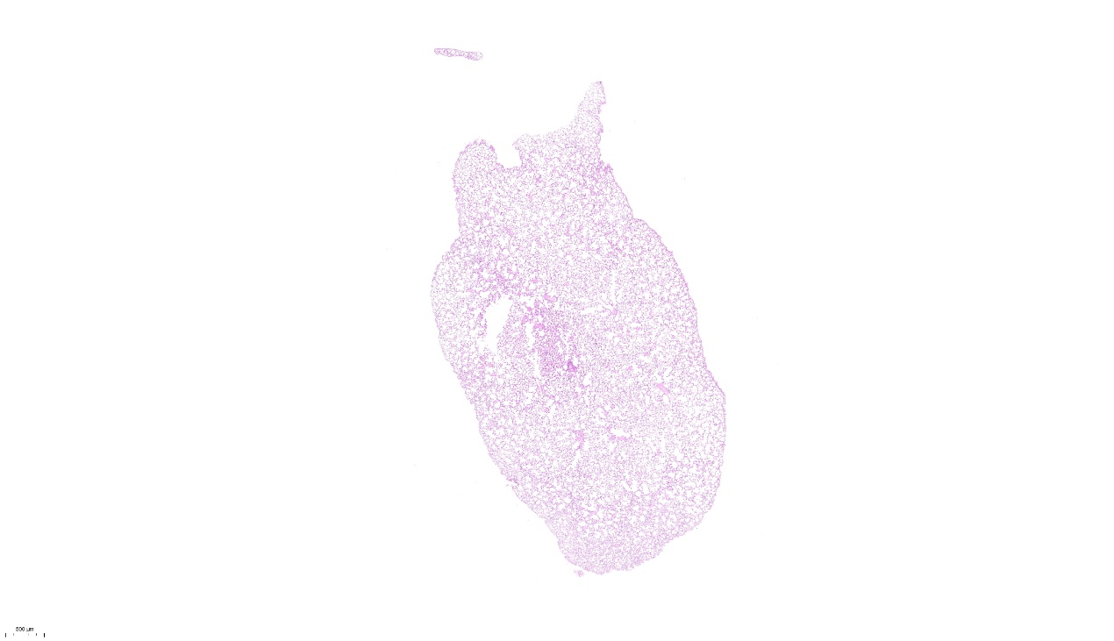

**The LPS+AMD group**

